Dialogs and Fragments
In this step, we will take a closer look at another element which can be used to assemble views: fragment.
Fragments are light-weight UI parts (UI subtrees) which can be reused but do not have any controller. This means, whenever you want to define a certain part of your UI to be reusable across multiple views, or when you want to exchange some parts of a view against one another under certain circumstances (different user roles, edit mode vs read-only mode), a fragment is a good candidate, especially where no additional controller logic is required.
A fragment can consist of 1 to n controls. At runtime, fragments placed in a view behave similar to "normal" view content, which means controls inside the fragment will just be included into the view’s DOM when rendered. There are of course controls that are not designed to become part of a view, for example, dialogs.
But even for these controls, fragments can be particularly useful, as you will see in a minute.
We will add now a dialog to our app. Dialogs are special, because they open on top of the regular app content and thus do not belong to a specific view. That means the dialog must be instantiated somewhere in the controller code, but since we want to stick with the declarative approach and create reusable artifacts to be as flexible as possible, we will create an XML fragment containing the dialog. A dialog, after all, can be used in more than only one view of your app.
Preview
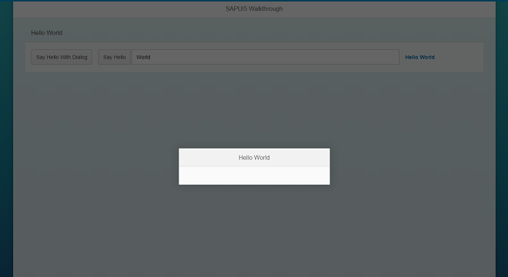
Figure 1: A dialog opens when the new “Say Hello With Dialog” button is clicked
Coding
webapp/view/HelloPanel.view.xml
<mvc:View
controllerName="sap.ui.demo.wt.controller.HelloPanel"
xmlns="sap.m"
xmlns:mvc="sap.ui.core.mvc">
<Panel
headerText="{i18n>helloPanelTitle}"
class="sapUiResponsiveMargin"
width="auto" >
<content>
<Button
text="{i18n>openDialogButtonText}"
press="onOpenDialog"
class="sapUiSmallMarginEnd"/>

<Button
text="{i18n>showHelloButtonText}"
press="onShowHello"
class="sapUiDemoWTmyCustomButton"/>
<Input
value="{/recipient/name}"
valueLiveUpdate="true"
width="60%"/>
<Text
text="Hello {/recipient/name}"
class="sapUiSmallMargin sapThemeHighlight-asColor sapUiDemoWTmyCustomText"/>
</content>
</Panel>
</mvc:View>
We add a new button to the view to open the dialog. It simply calls an event handler function in the controller of the panel’s content view.
webapp/view/HelloDialog.fragment.xml (New)
<core:FragmentDefinition
xmlns="sap.m"
xmlns:core="sap.ui.core" >
<Dialog
title="Hello {/recipient/name}">
</Dialog>
</core:FragmentDefinition>
We add a new XML file to declaratively define our dialog in a fragment. The fragment assets are located in the core namespace, so we add an xml namespace for it inside the FragmentDefinition tag.
The syntax is similar to a view, but since fragments do not have a controller this attribute is missing. Also, the fragment does not have any footprint in the DOM tree of the app. It is simply a container for a set of reuse controls.
webapp/controller/HelloPanel.controller.js
sap.ui.define([
"sap/ui/core/mvc/Controller",
"sap/m/MessageToast"
], function (Controller, MessageToast) {
"use strict";
return Controller.extend("sap.ui.demo.wt.controller.HelloPanel", {
onShowHello : function () {
…
},
_getDialog : function () {
if (!this._oDialog) {
this._oDialog = sap.ui.xmlfragment("sap.ui.demo.wt.view.HelloDialog");
this.getView().addDependent(this._oDialog);
}
return this._oDialog;
},
onOpenDialog : function () {
this._getDialog().open();
}
});
});
The internal _getDialog helper function is instantiating the fragment by calling the sap.ui.xmlfragment method with the path to the fragment definition as an argument. The function returns the instantiated controls for further use in the app. In our case this is the dialog that we would like to open.
We store the dialog as an internal pointer on the controller to be able to open the same instance again when another user action is triggered, and we add the fragment dependent on the view to be connected to the view’s model. A convenient side-effect is that the dialog will automatically be destroyed when the view is destroyed. Otherwise, we would have to destroy the dialog manually to free its resources.
webapp/i18n/i18n.properties
# App Descriptor
appTitle=Hello World
appDescription=A simple walkthrough app that explains the most important concepts of SAPUI5

# Hello Panel
showHelloButtonText=Say Hello
helloMsg=Hello {0}
homePageTitle=Walkthrough
helloPanelTitle=Hello World
openDialogButtonText=Say Hello With Dialog
dialogCloseButtonText=Ok
The text bundle is extended by two new texts for the open button and the dialog’s close button.
Conventions
- Always use the addDependent method to integrate the fragment into the control tree of the view.
- Private functions and variables should always start with an underscore.

